Reports > Analytics on clients.
This report allows you to group and to draw data sample on clients.
Availability of the report is regulated by setting up of access rights.
Warning! In order to avoid information leakage, the right to use the report should be assigned with due diligence. The report provides financial data on players, as well as information from their accounts.
To obtain results of the report, it is necessary to fill in the following fields in the tab «Filter»:
The period of the report.
Allows you to select the year, then the month in which the data sample will be carried out.
Drilling down a database.
Implemented with respect to the following parameters:
Address, Alternative Phone, City, Country , Phone, Date of Birth, Email, Name, Nick, Language, Last Name,Timezone – player data from the customer's card (Client Summary ).
Login – Customer`s login, generated by Fundist functionality during the player's registration;
RegistrationIP –login IP-address of a player;
LastLoginIP – IP-address from which a player was logged in last time;
CurrencyName – currency of account in the player's account;
In the future, the parameters marked «Orig» will indicate that the sample will be carried out in the original currency of the customer (parameter CurrencyName). Parameters marked «NGR» (net game revenue) indicate that the sample is carried out according to the amount of turnover from the games (total profit from a player).
Balance – the balance of a player at the end of a selected period in the Fundist currency of account;
BalanceOrig – the balance of a player at the end of a selected period in the currency of his account;
Bet Amount, Bet AmountOrig – the amount of all bets made by a player in the selected period;
NetBalance, NetBalanceOrig – the difference between the balance of a client and the amount that is locked by active bonus;
TotalDeposit, TotalDepositOrig – the total amount of all deposits of a player since his registration;
TotalNGR, TotalNGROrig – total profit from a player, received from the date of his registration;
TotalWithdraw, TotalWithdrawOrig – the total amount derived from the balance of a player from the moment of his registration;
TotalBonus, TotalBonusOrig – the difference between the amount, charged to the balance of a player on activated by player bonuses, and the amount, written off for non- turned over bonuses. The latter may include the amount of the bonus, win, amount of events that activates the bonus, and also balance written off from a player, if such condition was stated in the bonus.
FirstBonusDate – the date of the first bonus activation;
FirstDeposit, FirstDepositOrig – the amount of the first deposit of a player;
FirstDepositDate – the date of the first deposit to the balance of a player;
FirstGamingDate – the date of the first game played with the real rate;
FirstWithdrawalDate – the date of the first withdrawal of assets from the balance;
LastBonusDate – the date of last bonus activation;
LastDepositDate – the date of the last deposit;
LastGamingDate – the date of the last real-money gaming;
LastWithdrawalDate – the date of the last withdrawal of assets from the balance;
ThisMonthDeposit, ThisMonthDepositOrig – the amount of all deposits of a player for selected period (month);
ThisMonthNGR, ThisMonthNGROrig – total profit of a player for selected period;
ThisMonthWithdraw, ThisMonthWithdrawOrig – total amount of withdrawal of assets from the balance for selected period ;
LastMonthDeposit, LastMonthDepositOrig – the sum of all deposits of a player for the previous month (as regard to the month selected in the report);
LastMonthNGR ,LastMonthNGROrig – the amount of profit from a player for the previous month (as regard to the month selected in the report);
LastMonthWithdraw, LastMonthWithdrawOrig – total amount of withdrawal of assets from the balance of a player for the previous month (as regard to the month selected in the report);
LastSixMonthsDeposit,LastSixMonthsDepositOrig – the sum of all deposits of a player for the previous six months (as regard to the month selected in the report);
LastSixMonthsNGR, LastSixMonthsNGROrig – the amount of profit from a player for the previous six months (as regard to the month selected in the report);
LastSixMonthsWithdraw, LastSixMonthsWithdrawOrig – total amount of withdrawal of assets from the balance of a player for the previous six months (as regard to the month selected in the report);
MonthBeforeLastDeposit, MonthBeforeLastDepositOrig – the sum of all deposits of a player for second to last month (as regard to the month selected in the report); (*)
MonthBeforeLastNGR, MonthBeforeLastNGROrig – the amount of profit from a player for second to last month (as regard to the month selected in the report; (*)
MonthBeforeLastWithdraw, MonthBeforeLastWithdrawOrig – total amount of withdrawal of assets from the balance of a player for second to last month (as regard to the month selected in the report; (*)
(*) – If November is selected, the report will display data for September; If October is selected, the report will display data for August;
CRMCategory – information about Management Groups;
CRMManager – information about appointed Managers;
APILogin – API login of the player;
AffiliateSystem –affiliate name;
Sample parameters arranged in alphabetical order, but to simplify the search for the desired parameter, you can take the opportunity to search by name.
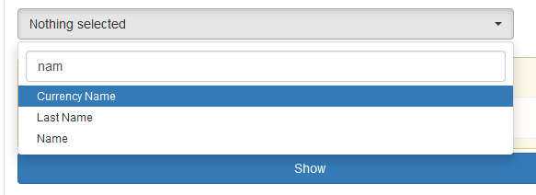
Selected parameters of this field will be subsequently names for the columns of the resulting report:
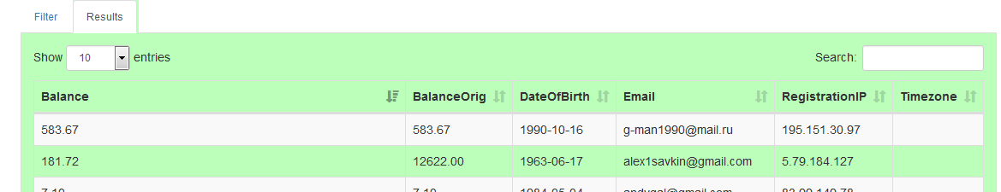
Search condition selection. In this part, you must specify what parameters and what rules will be used to display data on previously selected groups.
Rules suppose selection of a prerequisite, which is performed for the selection of data on players.
Simple condition.
Example 1: It is required for all previously selected groups (the columns of the report) to get the selection by a particular country or several countries. Suppose that in our case it will be Russian Federation and Latvia.
Actions: it is necessary to set the «Country» parameter in the field of rules, then select the desired type of condition (if option allows you to do this), and a value or a few values for this.
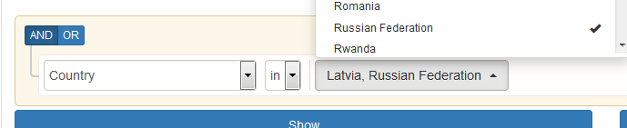
After pressing the «Show» push button, you will get:
Results:
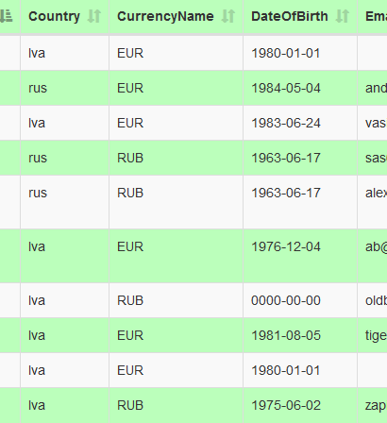
Rules can be multiple. Each new rule is added by pressing the «Addrule» push button. All added rules comply with elementary logic «AND» or «OR».
Conditions with the choice of «AND»:
Example 2: Let it be required to add the additional condition to the previous task: to display Balance, the amount of which is more than 50EUR, for all previously selected groups (the report columns).
Actions: click on the «Addrule» button, click on the «AND» button (the task is to select both by the country and by the Balance), and then select the desired parameter «Balance», satisfying condition «greater» and the necessary amount :
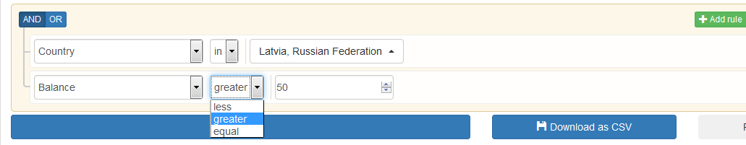
Results:
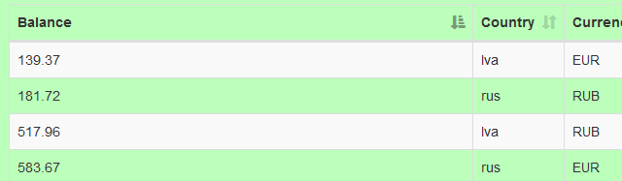
The results should be read as follows: for all of the selected groups in the report only those rows (where the following conditions are met: the country of players – Latvia and Russian Federation, and the balance of the players is more than 50 EUR) are displayed.
If you want to display balances of more than 10 but less than 50, it is possible to use such an option of conditions:
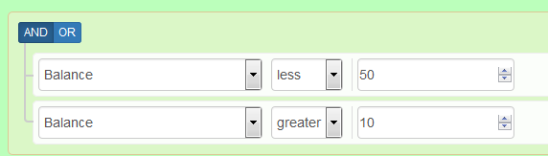
Conditions with the choice of «OR»:
The report displays the data of the groups, for which the logical condition is met, by its use the most approximate to the conjunction "or" in the sense of "one or the other, or both".
Example 3: It is required to get sample with the proviso that the report will include only those players who were born after 1989 or before 1975.
Actions : click on the «Addrule» button, click on the «OR», and then select the desired parameter «Balance», satisfying condition «greater» and the necessary amount:
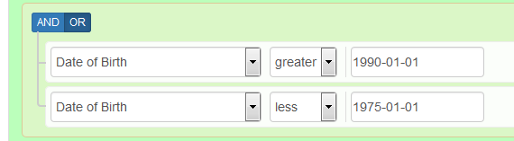
Results:
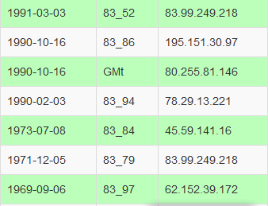
The results of the report should be read as follows: sample data are received for the players who were born after 1989 or before 1975. (Note: it is necessary to note that it would be impossible to obtain the desired result if you use the condition «AND»).
Example 4: It is required to get sample with the proviso that the report will include all the players from Russian Federation, as well as all the players that have RUB as currency of their accounts.
Actions:
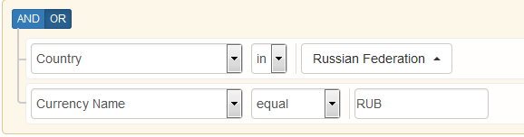
Results:
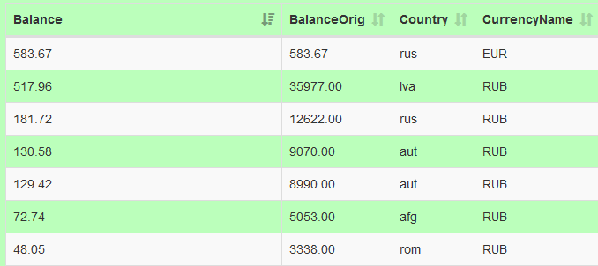
The report displays all players who have RUB as currency of their accounts and all the players from Russian Federation, no matter what currency these players have.
Adding a group of conditions.
At some time, you may need to create a combination of conditions, which will need clearly to use logical conditions «AND» and «OR» together.
Example 5: It is required to get a sample of all the players who have:
а) balance and the amount of bets greater than zero, and
b) RUB as currency of their accounts or Russian Federation as a selected country of their accounts (the condition of the previous example);
To add a group of conditions press «Addgroup» push button.
Actions:
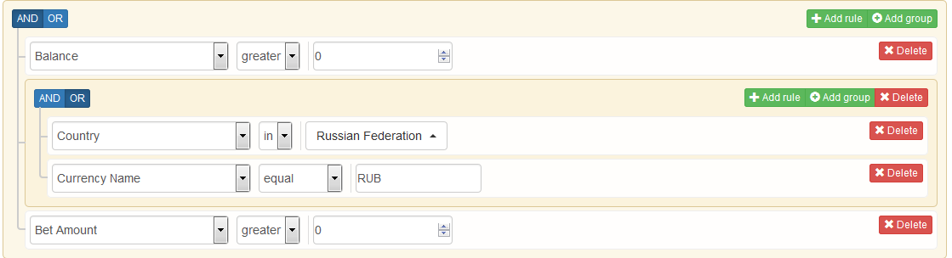
Results:
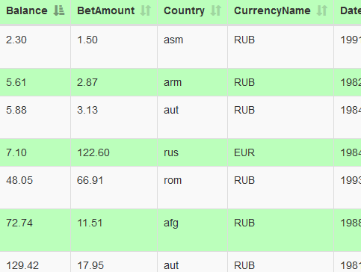
Conditions can be set between two or more groups of conditions.
Example 6: It is required to get a sample of the players from Austria and Russia, that have RUB or EUR as currency of their accounts.
Actions:
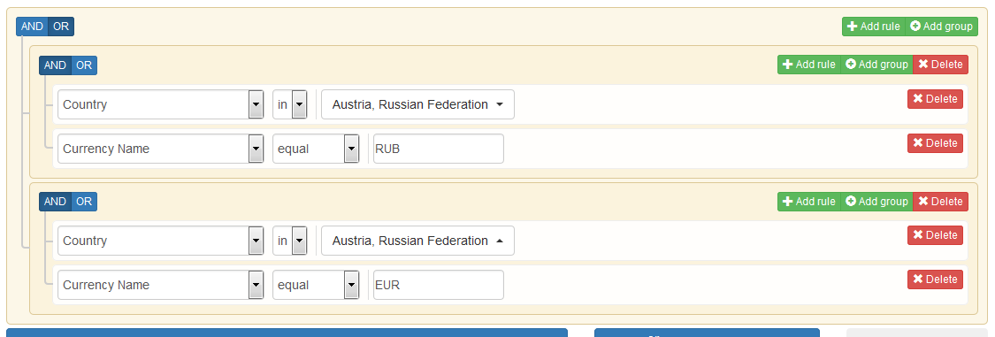
Results:
